**Risk Management: Pepsi Bottling Plant**

Lauren Alexandra

Colorado State University Global

CSC 501: Management for the Computer Science Professional

Dr. Charles Lively

May 20, 2021

**Introduction**

A Pepsi bottling plant based in Los Angeles has received a shipment of defective bottles. The bottles have a sixty percent failure rate under load and if shaken, the pressurized liquid leads to an explosion when opened. Unfortunately the defects can not be isolated and withdrawn from the shipment. At this time Pepsi must either initiate a full recall or issue a public service announcement. The first priority of the company is to inform affected consumers of the potential risk. The company must also be regulatory compliant; the Consumer Product Safety Commission and the Food and Drug Administration may instantiate a recall if the company fails to do so if appropriate (Wix & Mone, 2007). My team has performed a risk assessment in response to determine the best course of action.

**Assessment**

Risk can be understood through its severity and likelihood. One management tool for illustrating a potential risk and its impact is a risk matrix. The tool equips the company to respond appropriately to the identified risk: accept, mitigate, share or transfer the risk (Siegel, 2019). The company can not accept the risk and take no action. Not only is the response unethical but it would also likely lead to legal penalties. Pepsi will not be able to transfer reputational risk to suppliers either. The company needs to at minimum mitigate against the risk. For the present scenario, a sixty percent bottle failure rate under load and if shaken, our team devised a risk matrix (see Figure 1) to highlight where the company must apply its focus. Given the likelihood of the risk and the extent of the product defect, the risk outcome can be characterized as probable and tolerable.

**Figure 1**

*Risk Matrix*

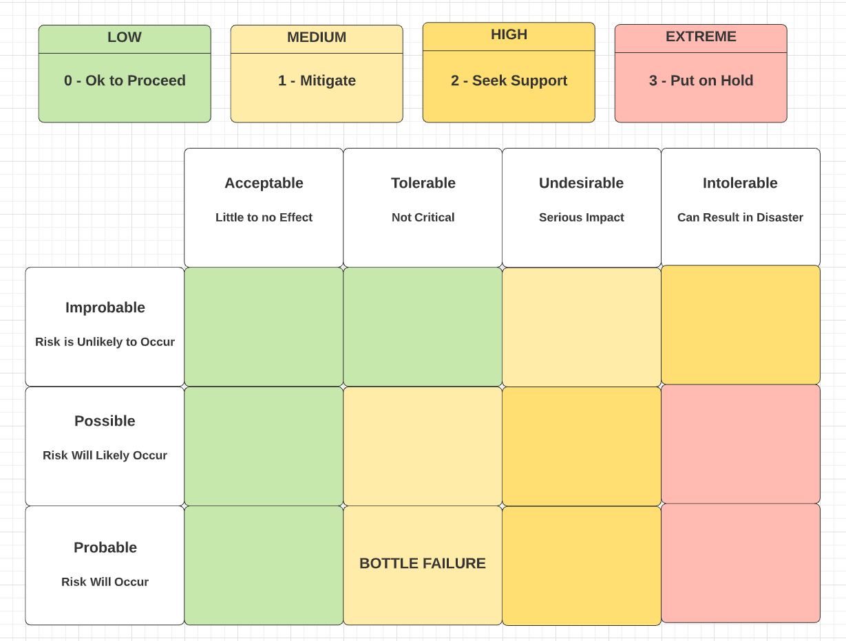

**Motivations**

The central question to answer when assessing a possible recall is whether or not a product has a legitimate safety issue. Furthermore, the company must evaluate the product defect’s nature, the threat level posed to consumer health and safety, the distribution of the defect throughout the product inventory, and whether or not the defect can be addressed (Wix & Mone, 2007).

If a full recall is necessary, the recall will elicit negative publicity and likely damage the company stock price (CNN Money, 1999). Additionally, a mishandled recall can leave a lasting impression on customers and a loss of reputation. A plan for the removal of defective products from the Pepsi distribution chain and marketplace must be created in preparation for a recall (Wix & Mone, 2007).

For instance, in 2017 Pepsi recalled its bottles for a failure in the manufacturing process (Associated Press, 2017). The recall was due to metal contamination and limited to a single state. In response the state issued a consumer advisory. The company was able to isolate the defect in bottles labeled with specific codes allowing for a controlled product removal and method of providing aggrieved customers with a refund. The scenario at hand gives the company no such option for a targeted removal. Whether Pepsi decides on a recall or a public service announcement, the company must mitigate both product liability and harm to overall company reputation.

**Recommendation**

My recommendation as project manager is to administer a public service announcement. The outcome of the risk event is not critical; a serious impact will not be felt by the consumer. Pepsi must act quickly to communicate the product risk and corrective measures to be taken. The company needs to develop a strategy for accomplishing an effective message; it should be actionable with a clear, required response from the consumer (Goodwill, n.d.). The announcement should frame messaging in such a way that features customer’s self-efficacy (Clare & Huddleston, 2014). Placing the locus of control in the hands of the consumer increases the likelihood that company product messaging will be successful.

**Conclusion**

Pepsi has faced failures in its manufacturing pipeline before. The company understands its obligation to customers, shareholders, and overseeing governing bodies. For every failure, the company has an opportunity to avoid legal, monetary and consumer health risks in addition to building trust with its customers. The risk presented by the bottle failure does not surpass the threshold for launching a full recall. Due to the nature of the defect, the consumer does not encounter a serious health threat. A well coordinated public service announcement can inform customers to take the advised precautions when handling the product and generate trust in the company’s perceived goodwill.

**References**

Associated Press. (2017, May 8). *“Metallic Taste” Leads to Pepsi Bottle Recall in*

*Michigan*. WKAR.

<https://www.wkar.org/post/metallic-taste-leads-pepsi-bottle-recall-michigan>

Clare, G. P. & Huddleston, P. (2014). Getting the Message: Framing Food Recall

Messages to Increase Consumer Protection Motivations. *Journal of*

*Communication in Healthcare*, *7*(1), 57-70.

CNN Money. (1999, July 12). *Coke Recall to Cost $103M.* CNN Money.

<https://money.cnn.com/1999/07/12/companies/cocacola>

Goodwill, B. (n.d.). *What Factors Make Great PSAs*. PSA Research Center.

<https://www.psaresearch.com/what-factors-make-great-psas-what-to-avoid>

Siegel, N. G. (2019). *Engineering Project Management.* John Wiley & Sons Ltd.

Wix, D. G. & Mone, P. J. (2007). Planning for and Implementing a Product Recall.

*Defense Counsel Journal*, *74*(3), 220-232.